Data Technician
Workbook
Week 6 Python

Name:
Course Date:
Table of contents
Day 1: Task 1 4
Day 2: Task 1 4
Day 2: Task 2 5
Day 4: Task 1 6
Day 4: Task 2 6
Day 4: Task 3 7
Course Notes 7
Python Additonal Resources 8
Exercise 1: You can complete training on this website. 8
Exercise 2: Complete exercise on Google Colab and share your notebook with the trainer. 8
Exercise 3: Complete exercise on Google Colab and share your notebook with the trainer. 9
Exercise 4: Challenge yourself on hackerrank. Solve Python | HackerRank 9
Exercise 5: Practice on CodingChef. Print Coding Chef Question in Python 9
Exercise 6: Kaggle Data Visualization: Learn Data Visualization | Kaggle 9
Exercise 7: Kaggle Pandas Tutorial: Learn Pandas | Kaggle 10
Exercise 8: Video: Learn Pandas in Under 3 Hours | Filtering, Joins, Indexing, Data Cleaning, Visualizations - YouTube 10

How to Share your notebook
- Select share
- Enter and add trainers’ email yusufs@justit.co.uk
- Make sure that you set General access to Anyone with the link.
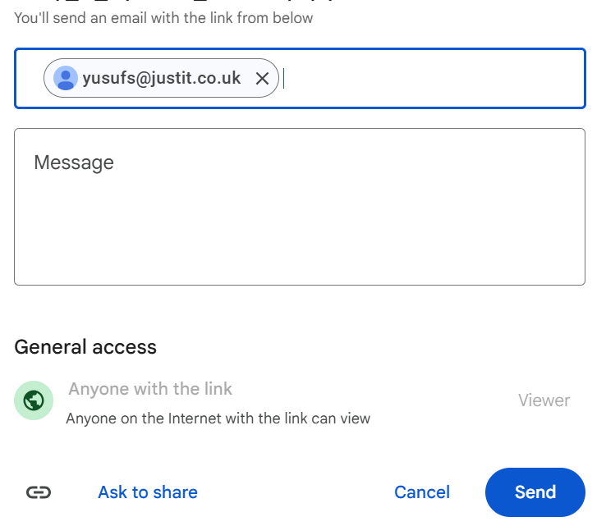
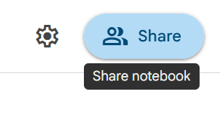
- Press send.

Day 1: Task 1
- Follow below link. https://colab.research.google.com/drive/1X2y7wcJ768lPnnq4HEOK2hpeefz3Bzl5?usp=sharing
- Save a copy of this notebook in your Drive and rename by adding your name to the end.
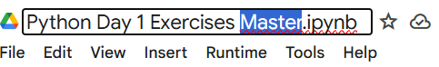

- Go through the notebook and complete the exercises at the end.
- Share your notebook with your trainer.

done

Day 2: Task 1
- Follow below link.
- https://colab.research.google.com/drive/1FMs6Dqg_tTSqn0wAuTa0aTX_vkYwkEJM?usp=sharing
- Save a copy of this notebook in your Drive and rename by adding your name to the end.
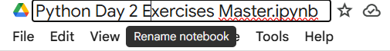

- Go through the notebook and complete the exercises at the end.
- Share your notebook with your trainer.

done

Day 2: Task 2

It is a common software development interview question to create the below with a certain programming language. Create the below using Python syntax, test it and past the completed syntax and output below.

FizzBuzz:

Go through the integers from 1 to 100.
If a number is divisible by 3, print "fizz."
If a number is divisible by 5, print "buzz."
If a number is both divisible by 3 and by 5, print "fizzbuzz."
Otherwise, print just the number.
Use loops and if statements.

Paste your completed work to the right | n = 1  while n <= 100:  if n % 3 == 0 and n % 5 == 0:  print("fizzbuzz")  elif n % 3 == 0:  print("fizz")  elif n % 5 == 0:  print("buzz")  else:  print(n)  n += 1

